clear all;

clc;

num=[0 0 2];

den=[1 0 2];

num1=[0 0 4 2];

den1=[1 3 4 2];

t=0:0.02:15

c1=step(num,den,t);

c2=step(num1,den1,t);

plot(t,c1,t,c2);

grid

title('Unit step responsated and compensated system');

x label('t sec');

y label('output');

text(2,0,88,'compensated system');

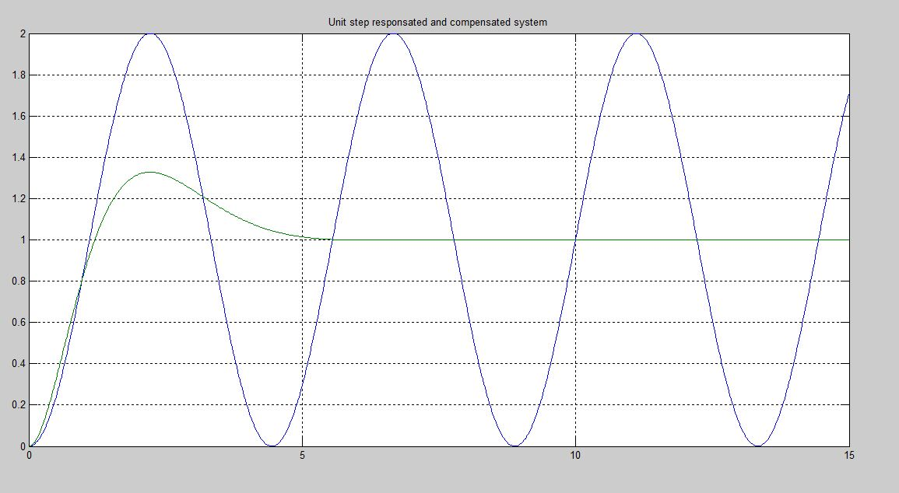text(3.1,1.48,'uncompensated system');